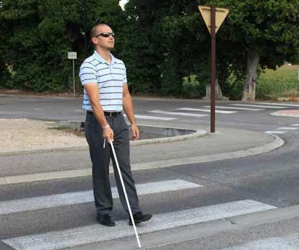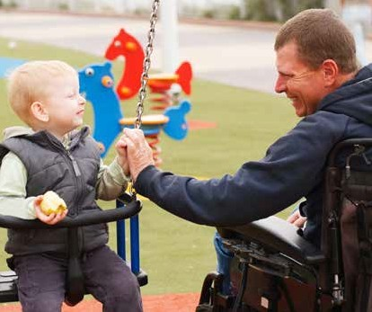

PAGE 01

A connected community for all

A connected community for all

Access and Inclusion Plan 2015-2020

PAGE 02

Message
from the Mayor

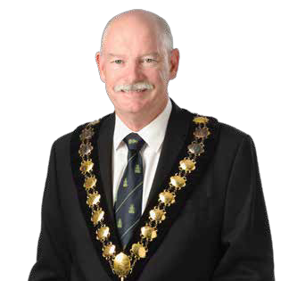I am pleased to present the City of Mitcham’s new Access and Inclusion Plan: A Connected Community for All to our community. The Plan sets out a shared vision to improve access and inclusion for all people who live in or visit the City of Mitcham.

Council values consultation with our community, and in developing this
Plan we sought input from people with diverse backgrounds and perspectives, and facilitated the involvement of people who often have the most difficulty in accessing and participating in community life. The community workshops, staff workshops, on-line surveys, telephone interviews and targeted focus group discussions, provided people who live and work in the City of Mitcham an opportunity to connect with Council to build a more inclusive and accessible community together.

Over the next five years, the whole community will benefit from the implementation of the Plan as we move from an ‘access’ to an ‘inclusion’ focus. Access ensures that every member of
the community can use the physical environment, transport, information and services equally. Inclusion moves beyond that by recognising that attitudes and expectations may exclude people just as much as lack of ramps or accessible parking.

We anticipate that Council will continue to have conversations with the community as the Plan is rolled-out, to ensure that we remain on track with our identified access and inclusion priorities.

The Plan provides us with an opportunity to assist people actively engage and contribute to the life of our community. By providing responsive services, accessible venues and infrastructure, and opportunities for people to genuinely participate within the community, we will facilitate greater social inclusion
and develop a stronger sense of shared community.

I look forward to working with the community as we implement our Access and Inclusion Plan.

Glenn Spear
Mayor of the City of Mitcham

PAGE 03

Mitcham:
A connected community for all

Some people with disability and their
carers need specialist supports to be able to
maintain everyday wellbeing at home, and
to be involved in community life.

It is important to have these specialist supports in place, and to work to improve their quality and accessibility.

However, a key imperative is for the broader community and mainstream services and facilities that are part of ordinary Australian life to be available and fully accessible for people with disability. That is, people with disability need to be able to access and use local doctors, dentists, shopping centres, sports clubs, transport, schools, websites, voting booths and so on.”1

1 Commonwealth of Australia 2011, National Disability Strategy 2010-2020, p. 13

PAGE 04

What is Access and Inclusion

To be part of the local community, people living with disability require buildings, streets, open spaces and services that are accessible and welcoming, along with transport suited to their needs.

Access refers to the removal or reduction of barriers (physical and attitudinal)
to participation in the activities and functions of a community.

Access is just one part of the broader context of inclusion.

“Inclusion is the process whereby every person (irrespective of age, disability, gender, religion, sexual preference
or nationality) who wishes to, can participate fully in all aspects of an activity or service in the same way as any other member of the community.”2

Many people living with disability experience a lack of inclusion rather than a lack of access.

The Disability Discrimination Act

Since 1993, the Disability Discrimination Act has prohibited discrimination against people with disability in a range of
areas including transport, education, employment, services, accommodation and premises used by the public. The
Act is based on the principle that people living with disability have the same rights as the rest of the community.

What does disability mean?

Disability includes physical, intellectual, psychiatric, sensory, neurological, and learning disabilities, as well as physical disfigurement, and the presence in the body of disease-causing organisms, whether from birth, or acquired through illness, accident or ageing, and people living with mental illness.3

2 http://www.acedisability.org.au/ information-for-providers/inclusion-in-the-community.php
3 Commonwealth of Australia (1992). Disability Discrimination Act Section 4.

PAGE 05

What is the
Access and Inclusion Plan?

The City of Mitcham recognises that people living with disability are valued members of our community who contribute to the vibrancy, diversity and prosperity of our City.

The City of Mitcham’s Access and Inclusion Plan 2015-2020 sets out Council’s commitment to ensuring our City is a welcoming and inclusive place beyond the requirements of the Disability Discrimination Act. We have developed priorities that will assist residents to move about and actively participate and contribute in the life of our community.

The Plan sets out our obligations under the United Nations Convention of the Rights of Persons with Disabilities, and aligns with Commonwealth and State Government initiatives which emphasise the choice, dignity and rights of citizens living with disability to live valued lives in inclusive communities.
The Plan links with the City of Mitcham’s Strategic Plan, Business Plan, Wellbeing Plan and Youth Plan. It sets out the goals and actions that will enable the City to provide services, supports, facilities and information that are not just accessible for all, but genuinely inclusive. The challenge is to move beyond buildings, footpaths, parks and other infrastructure to incorporate socially inclusive planning.

The Plan has been informed by the views and experiences of people living with disability, family members, local community services and Council staff involved in a series of targeted consultations.

The Plan will be implemented over five years, commencing in 2015,with a major review of the Plan to be conducted in 2020.

PAGE 06

Why is the Plan important?

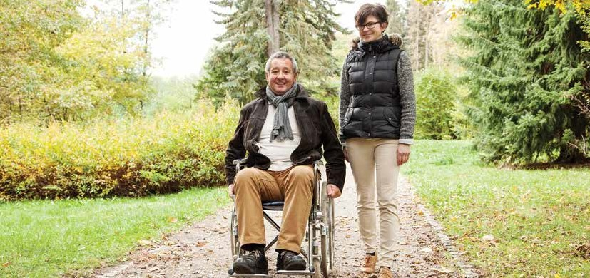The City of Mitcham’s Access and Inclusion Plan 2015-2020 demonstrates our commitment to supporting people living with disability access the services and supports needed to be actively involved as valued and contributing members of our community.
It is estimated that more than 20,000 people living in the City of Mitcham have access and inclusion needs. According to the 2011 Census the number of residents in the City of Mitcham who identified as living with severe and profound disability was 2,578 with approximately 20% of the population having some form of disability, limitation or impairment. Added to this are the families of approximately 3,500 children aged 0-4 years who use strollers and prams, and the more than 11,000 people over the age of 65.

PAGE 07

What people told us
about Access and Inclusion

During the consultation phase of developing this Plan, residents and people who regularly visit the City of Mitcham provided positive feedback on a number of access improvements that have been implemented throughout the City, such as connectivity of footpaths and parking.

Particular areas for further work were noted, including making open spaces more accessible, providing more accessible parking, continuing to improve footpaths and kerb ramps and upgrading access to some Council- owned buildings.

Participants highlighted that building a better community includes creating an
environment that is inclusive, engaging and considers the diverse needs of all residents.

Facilitating greater social inclusion was emphasised particularly around developing a sense of community for those at risk of isolation, and increasing engagement and participation in local events and everyday activities in the City of Mitcham.

The consultation process in developing the Plan highlighted more actions to improve access and inclusion than can realistically be achieved between 2015 and 2020. Council undertakes to consider any outstanding actions when
the Plan is reviewed in 2020.

PAGE 08

How will the Plan work?

Not all people living with disability are alike. People with disability have specific needs, priorities and perspectives based on their personal circumstances, including the types and level of support required4. The City of Mitcham’s Access and Inclusion Plan sets out goals, priority actions and anticipated outcomes for our community. It is based on the six key outcome areas of the National Disability Strategy 2010-20204, an initiative of the Council of Australian Governments. The Strategy sets out a ten year plan for improving the lives of Australians living with disability, their families and carers.

These priority areas are:
To achieve outcomes across the priority areas Council will either/or:

Inclusive and Accessible Communities

Economic Security

PARTNER: Council will contribute funds and/or resources towards the delivery of a service or initiative

Personal and Community Support
FACILITATE: Council will lead or participate in the process of bringing stakeholders together

Learning and Skills

Health and Wellbeing
ADVOCATE: Council will lobby
in support of people living with
disability and others with access
and mobility considerations

Rights Protection, Justice and Legislation
DELIVER: Council will directly deliver the service or initiative

An overview of each of these outcomes, along with Council’s priorities for each area, is provided in the following pages.

4 Commonwealth of Australia 2011, National Disability Strategy 2010-2020

PAGE 09

Inclusive and Accessible
Communities

GOAL: People with disability live in accessible and well designed communities with opportunity for full inclusion in social, economic, sporting and cultural life.

PAGE 10

Inclusive and Accessible
Communities

GOAL: People with disability live in accessible and well designed communities with opportunity for full inclusion in social, economic, sporting and cultural life.

Council Role:
Mitcham Council recognises that residents living with disability benefit by being actively included in the life of the City, including being able to move easily about their community on footpaths, in buildings, parks and toilets.

Priority Actions
In the next two years Council will:

• Ensure principles of access and inclusion are considered in the design, development and construction of all Council urban design projects such as buildings, parks, new and renewed footpaths, kerb ramps and crossings, bus stops, toilets, parking and
signage.

• Develop and implement consultative approaches to strengthen the involvement of citizens living with disability in access and inclusion issues.

• Review Council’s communication methods to strengthen connectivity to Council services, facilities, infrastructure and activities in and around the City.
In the next five years Council will:

• Provide training and support for relevant staff on accessible design.

• Review the Community Bus and personal transport services to improve availability, access and responsiveness.

• Provide Council information in a range of alternate or accessible formats.

• Disseminate relevant Council information through key disability, carer and community groups.

• Explore ways to support citizens make their homes more accessible.

Anticipated benefits to the community include:

• Improved access to infrastructure
and open space areas as principles of
access and inclusion are increasingly
incorporated into design and
construction.

• Improved Community Bus and personal transport services.

• Increased participation by people living with disability in the decision making processes of Council.

• Greater range of Council information available in accessible formats.

PAGE 11

Economic Security

GOAL: People with disability, their families and carers have economic security, enabling them to plan for the future and exercise choice and control over their lives.

PAGE 12

Economic Security

GOAL: People with disability, their families and carers have economic security, enabling them to plan for the future and exercise choice and control over their lives.

Council Role:
Mitcham Council recognises that the economic security of residents living with disability is improved through meaningful and appropriately remunerated employment as well
as reliable and inclusive services.
Priority Actions
In the next two years Council will:

• Strengthen Council recruitment policies for staff and volunteers to increase employment opportunities.

• Pro-actively engage with specialist disability employment agencies to promote and encourage people living with disability to apply for positions at Council.

In the next five years Council will:

• Explore opportunities to actively promote and support the employment of people living with disability in local businesses and within Council.

• Consider physical infrastructure to remove barriers and encourage employment for people living with disability.

Anticipated benefits to the community include:

• Increased opportunities and supports for people living with disability to gain employment within Council and the broader City of Mitcham.

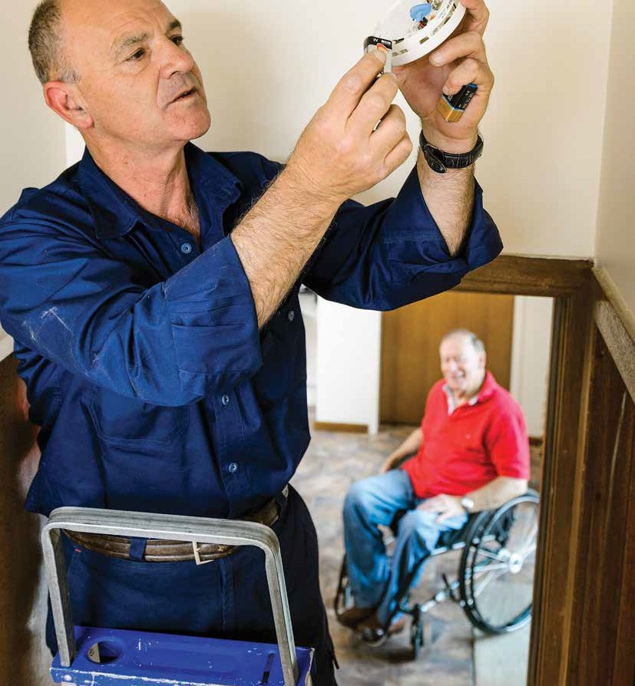PAGE 13

Personal and Community Support

GOAL: People with disability, their families and carers have access to a range of supports to assist them to live independently and actively engage in their communities.

PAGE 14

Personal and Community Support

GOAL: People with disability, their families and carers have access to a range of supports to assist them to live independently and actively engage in their communities.

Council Role:
Mitcham Council recognises that delivering services in an inclusive manner enables residents living with disability to access general and targeted services specific to their needs.

Priority Actions
In the next two years Council will:

• Incorporate disability customer awareness training into human resource development strategies.

• Arrange for relevant staff or volunteers to undertake customer disability awareness training to best support citizens with diverse needs.

• Explore ways Council can increase community linkages to support people living with disability to remain living independently in their homes.
• In the next five years Council will:

• Provide extension training for key staff and refresher updates for existing staff and volunteers.

• Consider the range of access and inclusion needs when Council is planning or supporting local events.

• Explore ways Council can increase opportunities for people to connect with their local community.

• Develop strategies to engage people living with disability in the planning and delivery of accessible and inclusive Council services and events.

Anticipated benefits to the community include:

• Strengthened staff and volunteer awareness and understanding of disability issues. Inclusive attitudes, and improved knowledge, skills and confidence in providing services to a diverse community demonstrated by Council staff.

• Increased support for people with disability to be connected to the community and retain independence.

PAGE 15

Learning and Skills

GOAL: People with disability achieve their full potential through their participation in an inclusive, high quality, education system that is responsive to their needs. People with disability have opportunities to continue learning throughout their lives.

PAGE 16

Learning and Skills

GOAL: People with disability achieve their full potential through their participation in an inclusive, high quality, education system that is responsive to their needs. People with disability have opportunities to continue learning throughout their lives.

Council Role:
Mitcham Council recognises that facilitating and advocating skill development of residents living with disability assists all people to
contribute to the life and vibrancy of the city.

Priority Actions
In the next five years Council will:

• Explore linkages with community organisations that promote life-long learning and training opportunities for people living with disability.

Anticipated benefits to the community include:

• Increased numbers of local education or training opportunities in the community that are affordable and encourage people living with disability to develop their skills, knowledge and experience.

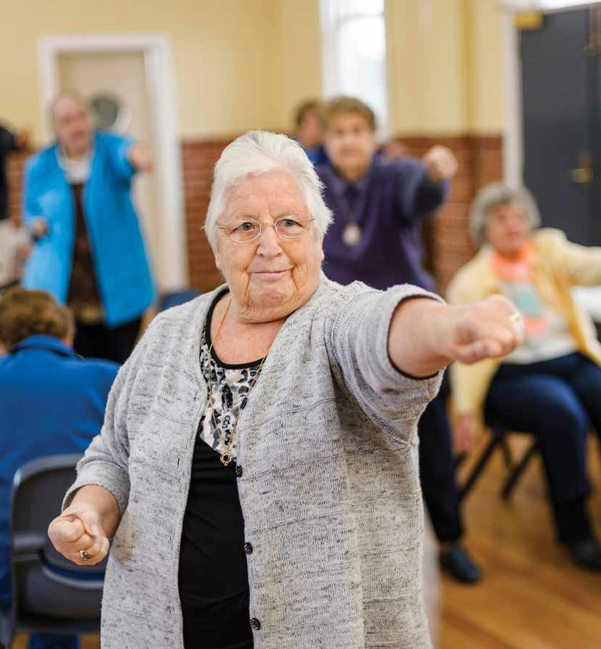PAGE 17

Health and Wellbeing

GOAL: People with disability attain the highest possible health and wellbeing outcomes throughout their lives.

PAGE 18

Health and Wellbeing

GOAL: People with disability attain the highest possible health and wellbeing outcomes throughout their lives.

Council Role:
Mitcham Council recognises that facilitating and linking residents living with disability to local health related programs and services improves health outcomes.

Priority Actions
In the next two years Council will:

• Explore opportunities as part of
the Regional Health and Wellbeing
Plan to support residents living with
disabilities access health services and
supports in the City of Mitcham.

• Ensure efforts to improve access and inclusion are integrated with other Council and State Government strategies in health and ageing.

Anticipated benefits to the community include:

• Greater range of information communicated to citizens about available local health services.

• Improved access and uptake of health services and supports.

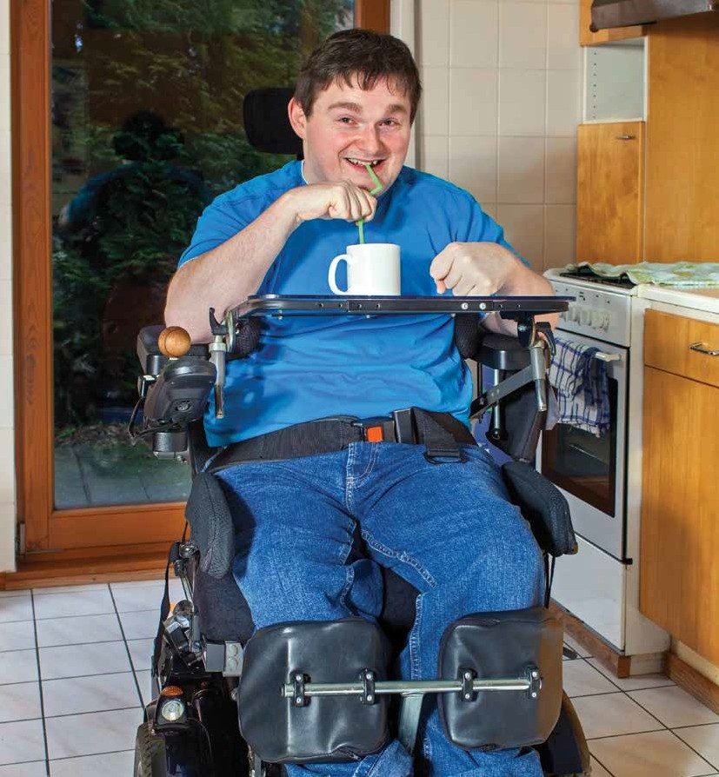PAGE 19

Rights Protection, Justice and Legislation

GOAL: People with disability have their rights upheld, promoted and protected.

PAGE 20

Rights Protection, Justice and Legislation

GOAL: People with disability have their rights upheld, promoted and protected.

Council Role:
Mitcham Council recognises that residents living with disability
will benefit from being supported to understand their rights as they relate to Council services.
Priority Actions
In the next two years Council will:

• Review Council complaints procedure to strengthen engagement with people living with disability, including multiple ways to register complaints and issues.

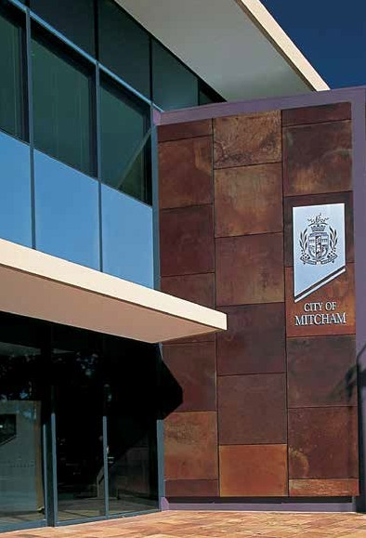In the next five years Council will:

• Investigate opportunities for education for residents and business operators to better understand disability, and the Disability Discrimination Act.

• Ensure changes made by local businesses/owners to their facilities are compliant with access standards.

Anticipated benefits to the community include:

• Greater community understanding of access and inclusion issues resulting in increased accessibility to local businesses.

• Improved and expanded ways to register complaints and issues with Council.

PAGE 21

How can you contribute?

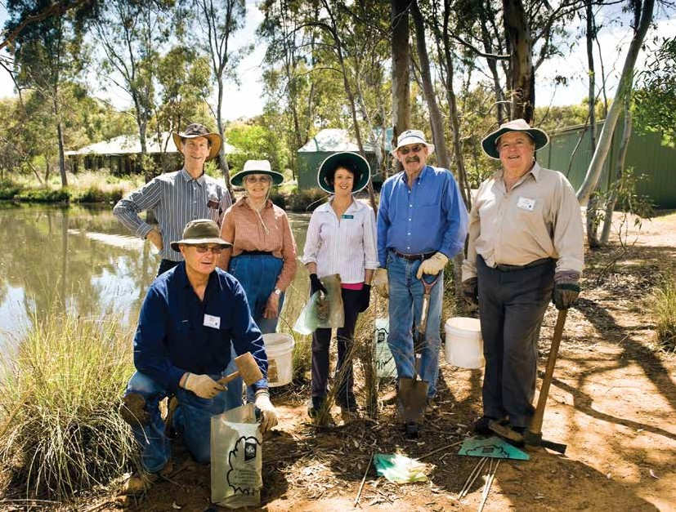The City of Mitcham’s Access and Inclusion Plan provides the opportunity for Council to work with our community to establish the effectiveness of improvements and innovations in access and inclusion.
Council welcomes feedback on the
Access and Inclusion Plan from all
people involved with the City of Mitcham
via Council’s ‘Have Your Say’ webpage,
email, phone or letter. Council contact
details are available on the back page of
this document.

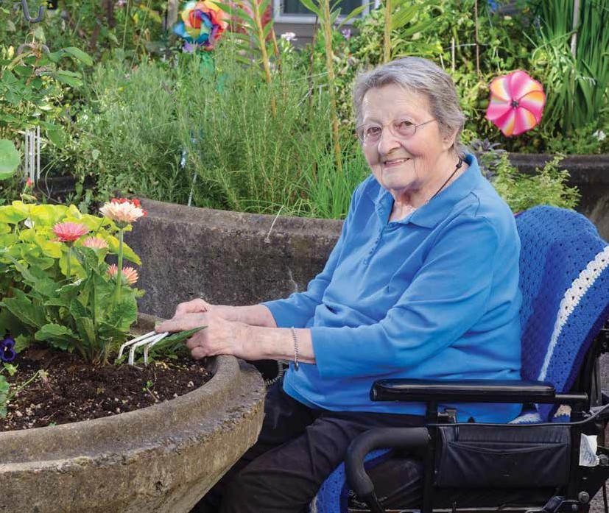

City of Mitcham

131 Belair Road
Torrens Park SA 5062

PO Box 21 Mitcham Shopping Centre
Torrens Park SA 5062

Telephone: 8372 8888

Email: mitcham@mitchamcouncil.sa.gov.au

Website: www.mitchamcouncil.sa.gov.au

Larger print or other languages available on request.

