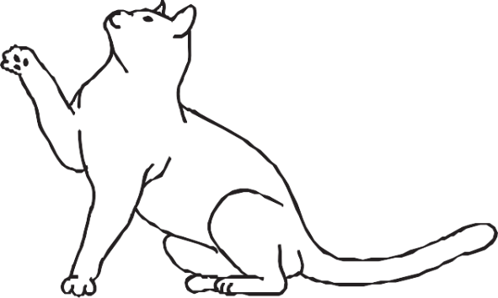
Dear Neighbour

I hope this note finds you well. I am writing to you to let you know about something involving your cat that I’ve noticed recently. It seems your feline friend has been exploring the neighbourhood and occasionally ends up on my property, causing a bit of a disturbance.

Before considering involving the City of Mitcham, I thought it best to reach out to you directly. I believe in resolving issues between neighbours amicably whenever possible. Here are some observations I've made regarding your cat's behaviour:

☐ Engaging in fights with other neighbourhood cats
☐ Emitting loud yowls
☐ Using my garden as their personal restroom
☐ Spraying urine
☐ Engaging in hunting behaviours that may impact the local wildlife

I understand if you may not have been aware of your cat's adventures beyond your own property, so I wanted to kindly bring this to your attention. Being a responsible pet owner means ensuring that our furry companions don’t cause any disturbances or harm to others in the community.

I trust that you'll take the necessary steps to address this matter. Let's work together to ensure harmony within our neighbourhood.

Thank you for your understanding.

Thank you

Your neighbour
[Your name]

